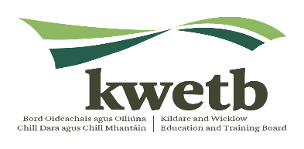
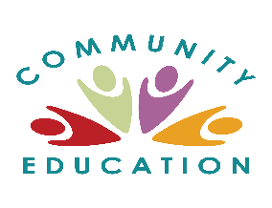
Community Education
Learner Enrolment Form

We are funded by the Dept of Education and Skills and must report on how we use the funding. If you do not provide the information, it means your participation is not counted and may lead to a reduction in funding for our work. Please complete all questions in block capitals. If you wish to protect the privacy of your information, please return it in a sealed envelope.

Course ___________________________________________________ Location ______________________

Name ___________________________________________________ Gender _______________________
Print name as you would like it to appear on your certificate.

Address ___________________________________________________ Eircode _______________________

Date of Birth _____________________ PPSN ________________________ Nationality _____________________

Mobile _______________________ Email _________________________ Emergency _____________________
A mobile will allow us to text you any class changes. Contact
Economic Status and Social Welfare Details
Employed full-time Employed part-time Unemployed Student/trainee
Engaged in home duties Retired Other, please specify ___________________________________
In receipt of social welfare payment. If yes, what is the payment? ______________________________________
How long have you been in your current category? ______________________________________
Education and Training History Please give details of your highest education level.
Level of Course | Name of Course | Year Finished | Country (if outside Ireland)
Is there anything else you wish to let us know? Please include relevant medical information.

_______________________________________________________________________________________________

Yes! I would like to receive information about learning opportunities from CE via SMS Email
(You will receive an email to confirm your subscription)
I consent to KWETB CE using my photo and/or video recording of me to promote their work
Data Protection Statement
I understand that my data may be shared as approved by the Department of Education and Skills, SOLAS, and KWETB to monitor the impact of Community Education. I understand that under the Data Protection Act, personal information recorded on paper or computer must be stored safely and treated as confidential. It will never be made available publicly in any way which could identify an individual person. It will only be used for the purpose for which it was gathered. I understand that I may also address any questions, comments and/or access requests regarding my personal details to dataprotection@kwetb.ie. More information can be found on www.communityeducationkwetb.ie

I acknowledge that the above details are correct ____________________________ _ __________________
Signature of Participant Date

Return to: Community Education, FETCN, Jigginstown, Naas, Co. Kildare. Revision: Oct 2019

