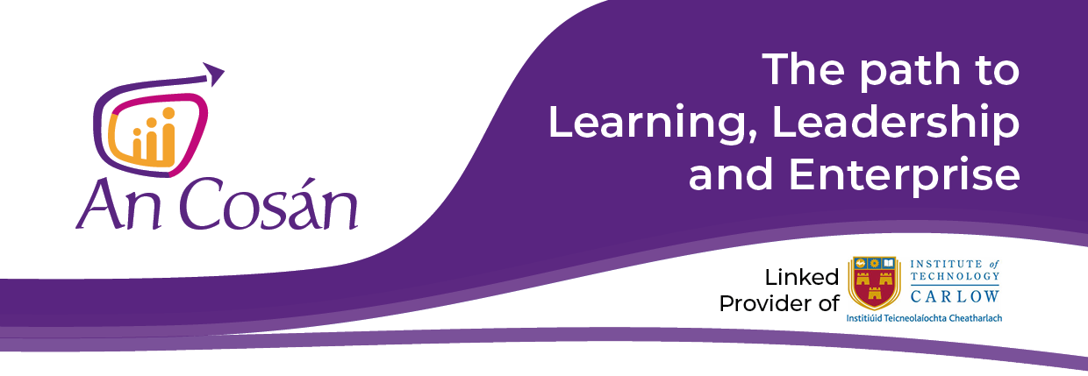
Transformative Community Education
NFQ Level | NFQ Level 7
Duration | 7 weeks
Format* | - Induction Day: Welcome Workshop & Technology Induction (18:30-21:00pm)*  Online Sessions: Once a week for 2 hours every week for 7 weeks  Midway Workshop: Online Workshop Saturday 22nd May 2021 (10am-1pm)*  * Important Updates  Format and duration may be modified if part of a tailored or Certificate Programme.  In light of the most-to-date Covid-19 pandemic health advice, we are currently delivering all programmes fully online. All Face to face Workshops run fully online from 10-1pm
Fees | €300 - This programme is funded for eligible participants by Kildare Wicklow Education and Training Board
ECTS Credits | 10
Awarding Body | Institute of Technology Carlow
Next intake | 2021/2022 Academic Year

Please note: information given is accurate at the time of publication but subject to revision. Programmes will only run where viable.

Programme Overview

The Transformative Community Education programme will explore theoretical concepts of community education, lifelong learning transformation and social change. Analyse specific case studies in relation to community education, social action and transformation. Investigate and identify strategies and practical approaches to curriculum design, development and delivery for transformative community education and support digital citizenship and social media activism. Examine the Irish and European Union policy frameworks with regard to lifelong learning further education and training and community education. Support practitioners to appreciate the value of e-learning in community education through experiential engagement and support the continuing professional and educational development of practitioners in the sector.

Learning outcomes
On successful completion of this module students will be able to:
- Understand the theories of community education, social capital, social action and the power of working and learning together to build stronger communities.
- Identify key policy issues with regard to community education.
- Have learnt to apply skills and knowledge in their practice.
- Have developed their critical and reflective thinking.
- Continue to develop self-awareness, interpersonal skills, by reflective practice and application of their learning. Develop best practice in Community Education.
- Have an understanding of e-learning in delivering Community Education

Assessment component
As part of the assessment for this programme, learners will be required to complete a reflective journal throughout the programme, produce an academic essay and complete an online exam.
Teaching, Learning and Assessment
Students will acquire in-depth knowledge and develop research and problem-solving skills through work and enquiry-based learning, more formally structured tuition, and self-directed learning. They will develop competencies in the following transferable skills: written and oral communication, critical thinking, digital literacy, group collaboration, problem solving, planning & time management. A variety of assessment methods such as reflective journals, presentations, research projects, portfolios and assignments are used on the programme.

Learner Supports

At An Cosán, we support our learners fully so that they can achieve their full potential.
- Technology moderators provide technical support and encouragement to learners in advance of and during online sessions.
- Qualified tutors with in-depth classroom experience and subject matter expertise are readily available to discuss programme content.
- One-to-one online mentors are available throughout the programme.
- Learners are actively encouraged to support one another and build collaborative learning communities.

Time commitment
For accredited programmes, you need to be available for two full day workshops (2 x 6-hour face-to-face workshops) and 8 online sessions (2 hours per week). It is recommended that participants allocate a minimum of 3 hours per week for self-directed study to cover suggested readings and videos.
* Format may be modified if part of a tailored or Certificate Programme.

Entry Requirements
Applicants must be 18 years+. Applicants should have completed the Leaving Certificate or a QQI (FETAC) Major Award at Level 5 in leadership, community development studies or a related area. An Cosán welcomes applications on the basis of mature entry and/or recognition of prior learning. Mature applicants for courses must be 23 years of age or over on January 1st of the year of entry to the course. Applicants will be considered on a case-by-case basis in accordance with the Institute of Technology Carlow entry requirements. Applicants whose first language is not English will need to provide evidence of English language proficiency. Applicants may be required to attend an interview.

Admissions
We are currently accepting applications for programmes commencing in September 2021. Closing date for applications to Certificate or BA Degree Programmes is Friday 21st May 2021. Closing date for applications for Minor Awards (when places are available) is 3 weeks before the start date of module.

Fees
All 10-week accredited programmes are €300 per participant. The course fee includes a non-refundable deposit of €50 payable to secure a place. Please note that 50% of the fees must be paid upfront with the balance to be paid before the course finishes. Bursaries and phased payment options available for individual learners.
SUMMARY OF PROGRAMMES AND PROGRESSION PATHS

Introduction Programmes | Unaccredited | Duration: 6 weeks | Fee: €200
Introduction to Community Development | Introduction to Community Drugs Work | Introduction to Community Leadership
Introduction to Climate Change and Environment | Introduction to Gender Studies | Introduction to Citizenship and Social Action

Minor Awards | NFQ Level 6 | 10 credits | Duration: 10 weeks | Fee: €300
Learning to Learn at Third Level | Citizenship and Social Action | Community Leadership
Introduction to Social Enterprise Development | Group Work and Facilitation Skills | Community Development
Social Analysis | The Nature and Context of Addiction | Drug Prevention, Education & Awareness
Community Development Practical Approaches | Understanding and Managing Conflict in a Community Development Context | Reflective Practice, Knowledge, Skills & Attitude
Social Policy | Equality & Diversity | Leadership & Organisational Development
Introduction to Counselling and Motivational Interviewing | Approaches to Treatment and Rehabilitation | Foundations in Adult Learning
Learning to Collaborate | Communications | Critical and Ethical Thinking in a Changing World

Minor Awards | NFQ Level 7 | 10 credits | Duration: 10 weeks | Fee: €300
Community Development and Technology | Research Methods and Practice | Project Cycle Management in the Community and Voluntary Sector
Leadership and Social Change | Leadership in Practice | Drugs and Crime in a Global Context
Community Drug Work and Leadership in Practice | Transformative Community Education | Special Purpose Award in Technology Enhanced Learning

Certificate Awards| NFQ Level 6 | 60 credits | Duration: 1 year | Fee: €1,800

Certificate in Leadership and Community Development

Certificate in Applied Addiction Studies and Community Development

Certificate in Leadership and Social Enterprise

Certificate in Personal and Professional Development (*Funded programme. Registration fee of €200 per annum only)

Higher Certificate Awards (NFQ Level 6) | 120 credits | Duration: 2 years

Higher Certificate in Leadership and Community Development

Higher Certificate in Applied Addiction Studies and Community Development

Bachelor of Arts Awards (NFQ Level 7) | 180 credits | Duration: 3 years

BA Degree in Leadership and Community Development NFQ Level 7

BA Degree in Applied Addiction Studies and Community Development NFQ Level 7
Note: Institute of Technology Carlow is now a Designated Awarding Body (DAB). An Cosán is a Linked Provider of Institute of Technology Carlow awards. We offer a blended online Bachelor of Arts in Leadership and Community Development & Bachelor of Arts in Applied Addiction Studies & Community Development (NFQ Level 7). Learners who complete Stage 1 at QQI Level 6 of the NFQ (60 credits) are eligible to exit the programme with a “Certificate in Leadership and Community Development” or “Certificate in Applied Addiction Studies and Community Development” (Minor Award Level 6) or to progress to Higher Certificate (QQI Level 6) and BA Degree Award (NFQ Level 7).
For more information and to register a place contact our team:

Phone: (01) 462 8488 Email: info@ancosan.ie Web: www.ancosan.ie

